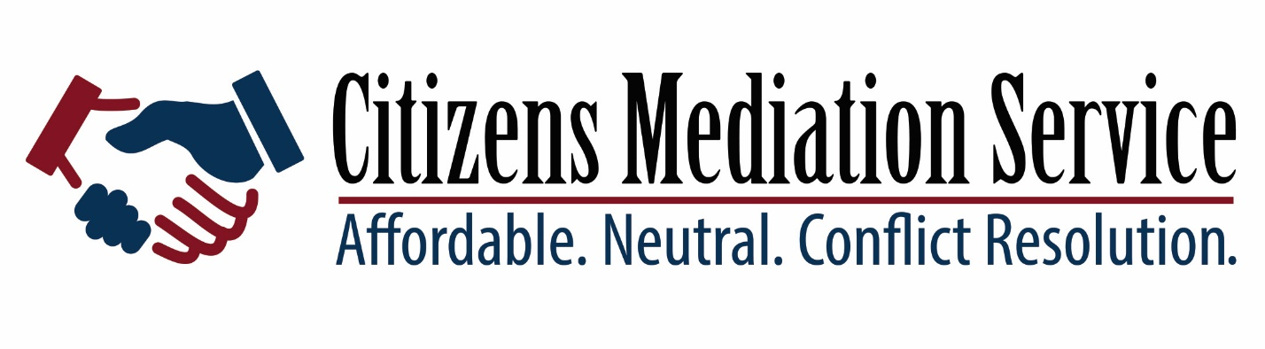
40 Hour Domestic Mediation Training
Citizens Mediation Service is proud to offer our community the opportunity to develop the skills required for successful Domestic Mediation – support families as they create solutions to life’s disagreements
This training is approved by SCAO to fulfill the mediation training requirement for MCR 3.26
You will:
Develop essential facilitation skills
Learn to engage in strategic negotiation
Examine theories and types of mediation
Dive into ethical issues related to the role of the mediator
Role play the experience of mediation

WHEN: April 13 – 17 8:30am – 5PM
April 20 DV Training 8:30 -5PM
WHERE: Cora Lamping Center, Building B
777 Riverview Drive, Benton Harbor
To reserve or place, or learn more about this opportunity please call 269-982-7898 or email jenny@citizensmediation.org
Our Trainer: Peg MacDougall is a 1984 graduate of Thomas M Cooley Law School. She has worked as a litigation attorney for 24 years before joining Resolution Services in 2011. Peg is an adjunct faculty member at Cooley Law School where she teaches Civil Mediation as well as interviewing and counseling, and pretrial skills. He also serves as a program manager for Resolution Services Center of Central Michigan.
$200 fee for participation is required – negotiable with volunteer time

